Office of Special Education

ICASE New Director’s Training
Resource Materials

July 23, 2014

Online Resources for Special Education: DOE Website

Indiana Department of Education Main Webpage: www.doe.in.gov
DOE COMPASS: School information, data, demographics
News Feed: News from all IDOE areas
Indiana Department of Education/Special Education Webpage: www.doe.in.gov/specialed
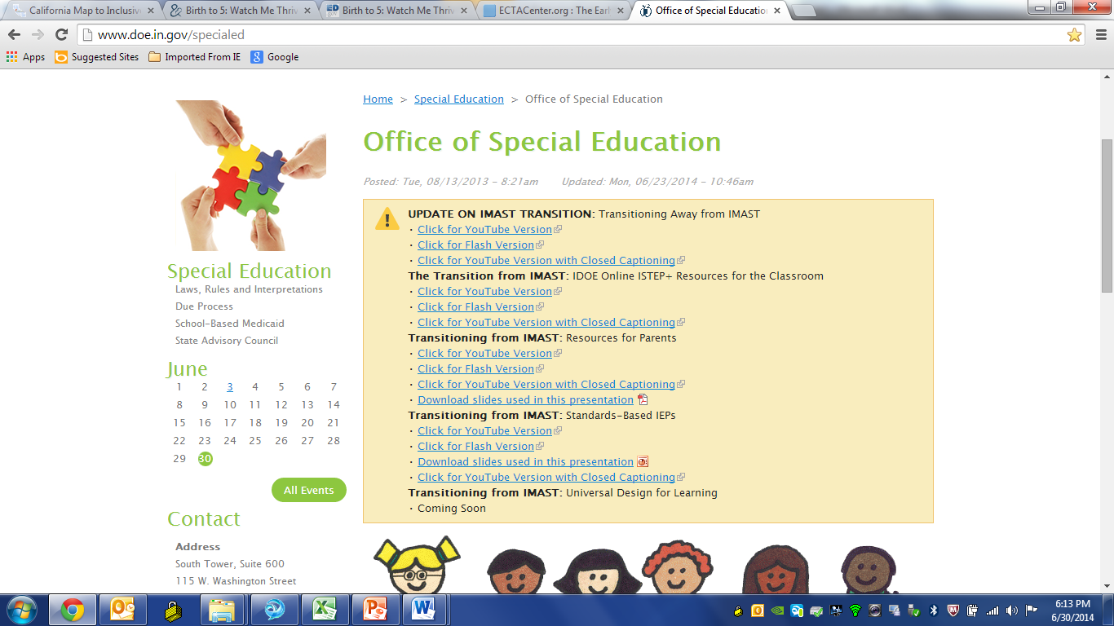3

Online Resources for Special Education: Learning Connection

The Learning Connection: https://learningconnection.doe.in.gov
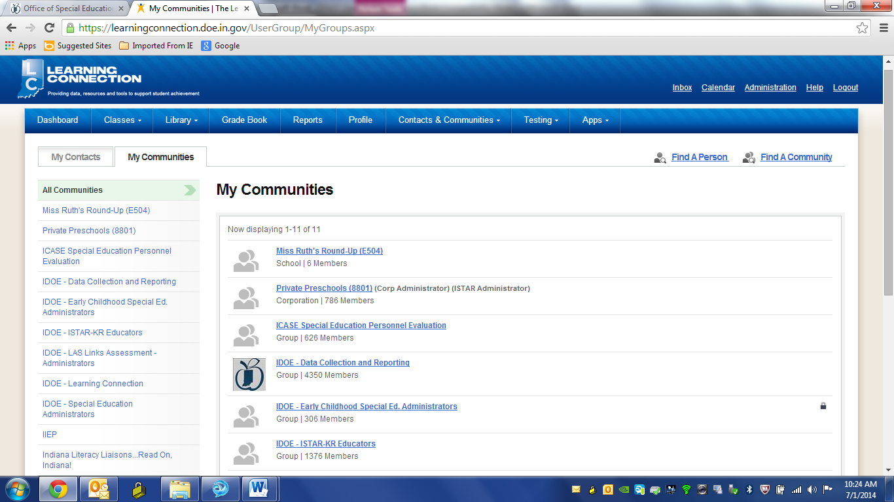
Join all IMPORTANT Special Education Communities:
- IDOE Data Collection and Reporting
- IDOE Special Education Administrators
- IIEP
- IDOE Early Childhood Special Ed Administrators
- IDOE-ISTAR Alternate Assessment Administrator Community
- IDOE-ISTAR Alternate Assessment Users
- IDOE-Medicaid in Schools

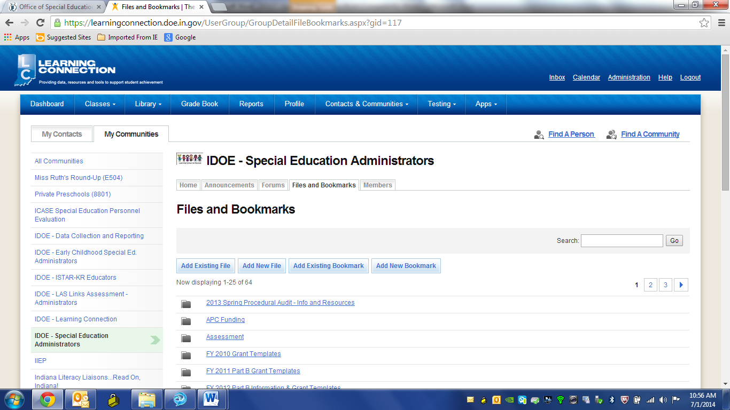
Documents for each Community are located in the “Files and Bookmarks” tab. All documents posted within an Announcement for the community can also be found here.

The data layouts used for DOE data collections are available on the Learning Connection in the IDOE- Data Collection and Reporting Community (Files and Bookmarks Tab). The layouts describe the different fields and what the various codes mean in each report.

Online Resources for Special Education: Application Center

STN Application Center: ac.doe.in.gov

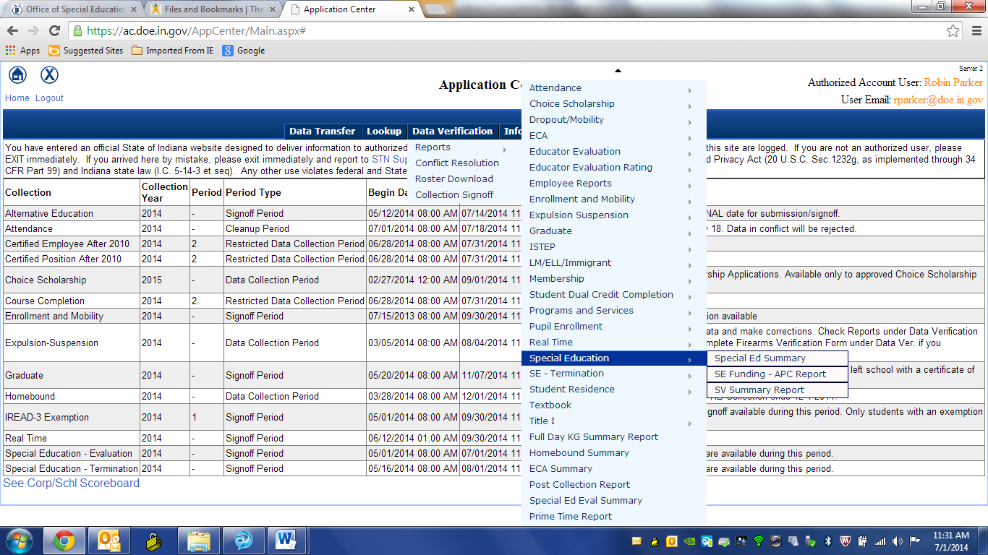
APC Funding tables and data that can be exported to Excel
Summary of data reported on DOE-EV
Summary of data reported on DOE-TR
Summary of data reported on DOE-SE
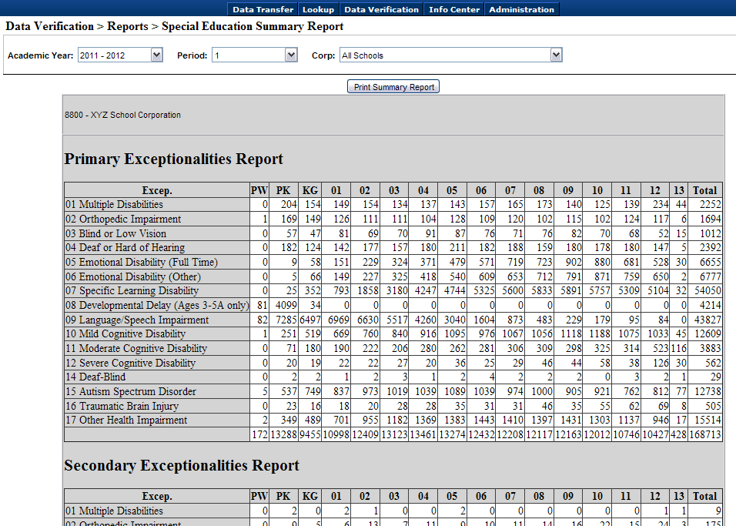

Child Count/State Funding

APC Funding
State Funding For Special Education

Additional Pupil Count (APC) funding is State monies to provide services and supports for students with disabilities. APC funding is based on the December 1 collection of the DOE-SE (Special Education) report as well as the DOE-ME (Membership) report. From the DOE-ME, the Average Daily Membership (ADM) type reported for a student is used to determine if the funds will flow to the Corp of Legal Settlement or the Corp of Service/Educating Corp as shown below:

MEMBERSHIP (DOE-ME) |  |  |  | SPECIAL EDUCATION (DOE-SE)
CATEGORY OF  STUDENT | INCLUDED IN ADM COUNT OF | ADM TYPE |  | INCLUDED IN SE COUNT OF | SE FUNDING ALLOCATED TO
Resident Enrollment | Educating Corporation | 1 |  | Educating Corporation | Educating Corporation
Transfers Out - Better Accommodations, Parent Placements and Physician Recommended Placement in  Health Care Facility | Corporation of Legal Settlement | 2 |  | Educating Corporation | Corporation of Legal Settlement
Transfers  (Rule S-5) | Corporation of Legal Settlement | 2 |  | Educating Corporation | Corporation of Legal Settlement
Cash Transfers | Educating Corporation | 3 |  | Educating Corporation | Educating Corporation
State Obligations | Educating Corporation | 4 |  | Educating Corporation | Educating Corporation
Placements In | Educating Corporation | 5 |  | Educating Corporation | Educating Corporation
Out-of-State Students | Not Applicable |  |  | Educating Corporation | Not Applicable

The Primary Exceptionality code reported for a student on the DOE-SE determines the student’s APC category or level, and each level generates a different monetary amount (IC 20-43-7-6), as shown below:

APC Level 1 ($8,350) | APC Level 2 ($2,265) | APC Level 3 ($533)
01 = Multiple Disabilities  02 = Orthopedic Impairment  03 = Blind or Low Vision  04 = Deaf or Hard of Hearing  05 = Emotional Disability (Full Time)  12 = Severe Cognitive Disability  14 = Deaf-blind  15 = Autism Spectrum Disorder  16 = Traumatic Brain Injury | 06 = Emotional disability (Other)  07 = Specific Learning Disability  10 = Mild Cognitive Disability  11 = Moderate Cognitive Disability  17 = Other health impairment | 09 = Language or Speech Impairment (primary or secondary exceptionality)  Students reported on the DOE-HB (Homebound) report who received homebound services for 20 or more consecutive instructional days (511 IAC 7-42-12). (see below)

APC Level 3: Duplicated Count
APC Level 3 includes all students who have been reported with Language or Speech Impairment (code 9 on the DOE-SE report) as the primary exceptionality OR as the secondary exceptionality. APC Level 3 also includes students reported on the DOE-HB (Homebound) report who received homebound services for 20 or more consecutive instructional days (511 IAC 7-42-12). This results in a duplicated count when you look at the total number of students for your APC funding.
The DOE-HB layout states:
Report data for students that receive instruction at home or at a hospital due to an injury or a temporary or chronic illness during the collection period, Dec 2, 2013, through Dec 1, 2014. Report data only on those students for whom the school has received a written statement from the student’s doctor or Christian Science practitioner, in accordance with 511 IAC 7-42-13, indicating that he student has an injury, temporary or chronic illness, or other medical condition that will require the student’s absence for an aggregate of at least twenty (20) instructional days. If there are fewer than 20 instructional days remaining in the school year, and the student needs instruction to meet promotion or graduation requirements, the statement must indicate that the student will be unable to attend school through the end of the school year.
APC Level 4: Preschool
The fourth APC level is Preschool, which generates $2750 per student, and includes preschools students ages 3-5A. A student is age “5A” if the student was not yet 5 years old on August 1 but turned 5 by December 1. The funding for the preschool level always flows to the Corporation of Legal Settlement and is not affected by ADM type.

511 IAC 7-48: The Expenditure of State Special Education Funds on Services to Nonpublic School Students with Disabilities
511 IAC 7-48 outlines both the explanation and requirements for the provision of special education and related services for students with disabilities who are placed by parents in nonpublic schools and requires School Corporations to expend all APC funds generated by nonpublic students on behalf of nonpublic students. This can include child find activities including evaluations, reevaluations, and independent educational evaluations; special education; and related services.

LEAs are monitored for compliance in regard to expending APC funds generated by nonpublic school students through the Fiscal and Procedural Audits. When an LEA is selected for participation in either of these Audits, the following forms must be submitted:
- Printout from DOE-SE showing the number of claimed nonpublic school students for the LEA.
- Worksheet showing the amount of money generated by parentally-placed nonpublic school students.
- Time and Effort Logs (PARs or Semi-Annual Certification) for all staff members serving students enrolled in nonpublic schools.

December 1 Special Education Child Counts

 | DOE-SE Summary | APC Funding | Part B Grants
Who does it count? | All Special Education students served by the corporation and reported by the corporation on the DOE-SE report. | All Special Education students reported on the Dec 1 DOE-SE report with an ADM type that directs funding to the corporation as well as students who received homebound services for 20 days or more. | All Special Education students reported on the Dec 1 DOE-SE report with an ADM type that directs funding to the corporation.
Is the count unduplicated? | Yes – Each student is counted only once. | No – Students who reported with Language/ Speech Impairment (9) as their secondary exceptionality code are counted for both their primary exceptionality and for LSI.  Students who received homebound services multiple times within a reporting period are only counted for APC funding once. | Yes – Each student is counted only once.
Where does the data come from? | DOE-SE (Special Education) | DOE-SE (Special Education)  DOE-ME (Membership) – for ADM type  DOE-HB (Homebound) | DOE-SE (Special Education)  DOE-ME (Membership) – for ADM type
Where can I find this count in the STN Application Center? | In the “Data Verification” menu, go to Reports → Special Education → Special Ed Summary. Select the year, Period 1, All Schools. | In the “Data Verification” menu, go to Reports → Special Education → SE Funding – APC Report. Select the year, Period 1, All Schools.  The Funding table will show the count. Export the “School Age (5B-22) table to Excel , and look at the “Corp Receiving Funding” column to see which students are included in this count.  The Homebound APC count is not currently available in the STN Application Center. You may contact the Office of Special Education for this count if desired. | In the “Data Verification” menu, go to Reports → Special Education → SE Funding – APC Report. Select the year, Period 1, All Schools.  Export the “School Age (5B-22) table to Excel, and look at the “Corp Receiving Funding” column to see which students are included in this count.

Part B Federal Funding

Name of Grant (IDOE): | FY 2012
Name of Grant (Federal): | FFY 2011
Grant Period: | July 1, 2011 - September 30, 2013
Begins with: | School Year 2011-2012
Ends with: | School Year 2012-2013
611 grant number begins with: | 14212
619 grant number begins with: | 45712
Name of Grant (IDOE): | FY 2013
Name of Grant (Federal): | FFY 2012
Grant Period: | July 1, 2012 - September 30, 2014
Begins with: | School Year 2012-2013
Ends with: | School Year 2013-2014
611 grant number begins with: | 14213
619 grant number begins with: | 45713
Name of Grant (IDOE): | FY 2014
Name of Grant (Federal): | FFY 2013
Grant Period: | July 1, 2013 - September 30, 2015
Begins with: | School Year 2013-2014
Ends with: | School Year 2014-2015
611 grant number begins with: | 14214
619 grant number begins with: | 45714

Name of Grant (IDOE): | FY 2015
Name of Grant (Federal): | FFY 2014
Grant Period: | July 1, 2014 - September 30, 2016
Begins with: | School Year 2014-2015
Ends with: | School Year 2015-2016
611 grant number begins with: | 14215
619 grant number begins with: | 45715

Special Education Reports
DOE-SE, DOE-EV, DOE-TR
 | DOE-SE | DOE-EV | DOE-TR
Name | Special Education Child Count | Special Education Evaluation | Special Education Termination
Description | Report to collect students for whom an initial evaluation for special education was conducted  (APC Funding, Part B Grants) | Report to collect students who are eligible and currently receiving special education services | Report to collect students who will no longer be receiving special education services
Indicators | 4A, 4B, 5, 6, 9, 10 | 11 & 12 | 1 & 2
Dates | Special Education students on December 1st and April 1st | July 1-June 30 | July 1-June 30
Important Tips | As the Corp of Legal Settlement, you can use the Corporation Cross Check report to ensure that Special Education students legally settled in your corporation that are being served in another corporation have been reported for funding. Please go to Data Verification>Reports>Special Education>Special ED Cross Check Report. You can also use the APC Report to see all students for whom you will receive funding. To view your SE Funding calculations in the STN Application Center, select Data Verification>Reports>Special Education>SE Funding-APC Report  Non-public students are included on your school’s SE report if they have IEPs or service plans and your school corporation provides special education services. In the situations described, enter the school number of the private school that students attend. If the private school does not have a state assigned school number, user ‘9999’  The Indiana School for the Deaf or Indiana School for the Blind will report students who have legal residence in a different school corporation but attend either of these schools because these schools provide the students’ special education services. These schools will report your corporation as the students’ corporation of legal settlement.  Additional funding is available for Language or Speech Impairment (Code 09) secondary exceptionalities. If one of the student’s secondary exceptionalities is Language or Speech Impairment, report the exceptionality. If Language or Speech Impairment is not one of the student’s secondary exceptionalities, it is irrelevant which secondary exceptionality is reported. | Only initial evaluations and early childhood transitions are required to be reported. Revaluations are not monitored through this report. Initial evaluations include 50-day timelines, 20-day timelines due to participation in an RTI process and expedited evolutions due to disciplinary actions.  For students receiving an initial evaluation, the date of referral is the date which school personnel received written parental consent to conduct the evaluation. For early childhood transitions, the date of referral is the date the student information was relayed from First Steps to the LEA.  If a student transfers out of an LEA during an evaluation, the LEA is no longer responsible for meeting the limits of the timeline. However, these evaluations should still be entered into the system and coded as a ‘student move out’ under Field 10 as a Code 3, Timeline missed, student withdrew from school during the evaluation process. The receiving school district may develop a new timeline with the parent(s) and/or guardian(s) of the child, but in no case may that timeline be longer than 50 instructional days. | Students who move to another public or private school in Indiana and continue special education services SHOULD NOT be reported on this report.

Unrestricted Federal Funds through Medicaid

http://www.doe.in.gov/specialed/school-based-medicaid

School-specific Medicaid claiming guidance, sample forms and other resources are available on IDOE’s School-based Medicaid Web page and at the Medicaid in Schools Community on the Learning Connection.
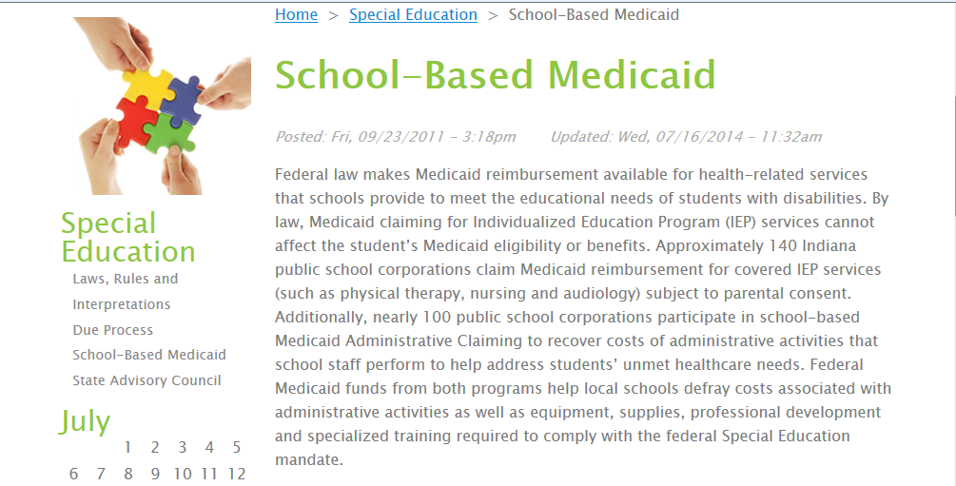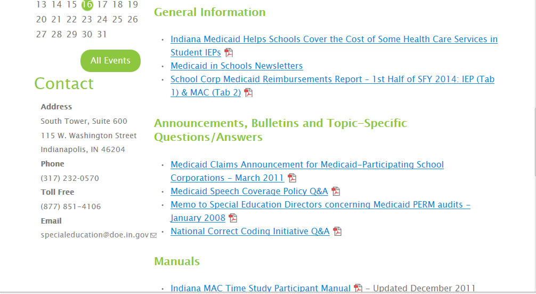
Click for Medicaid $ per district

The School Corp Medicaid Reimbursements Report shows the amount of federal Medicaid funds recovered per district under each claiming type (IEP and MAC). This report includes the number of Special Education students and Medicaid-enrolled students per district and it is a good tool for identifying similarly situated districts to contact for candid feedback about local staff experiences with school-based Medicaid claiming. See Page One of this report:

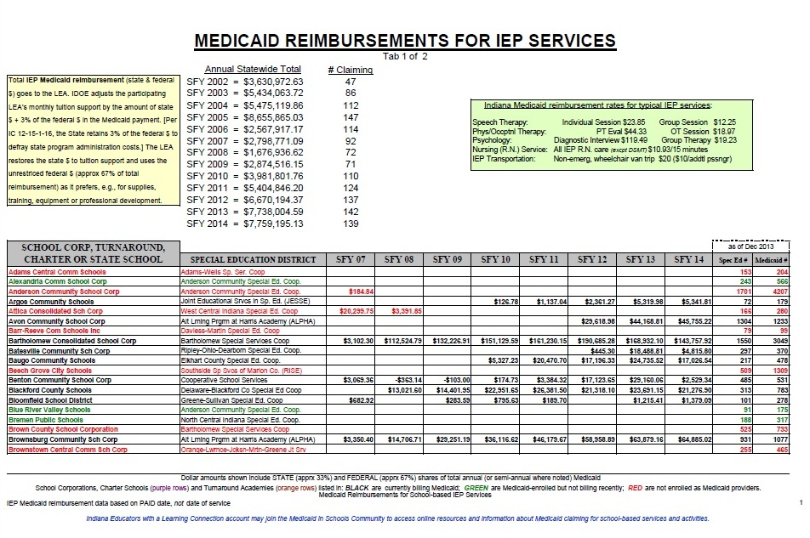
See pages 1-10 of the Report for IEP services reimbursements and counts of Total Special Ed Students and Total Medicaid-enrolled Students per participating district.

See pages 11-12 of the Report for MAC reimbursements and percentage of Medicaid-enrolled Students per participating district.

Learning Connection

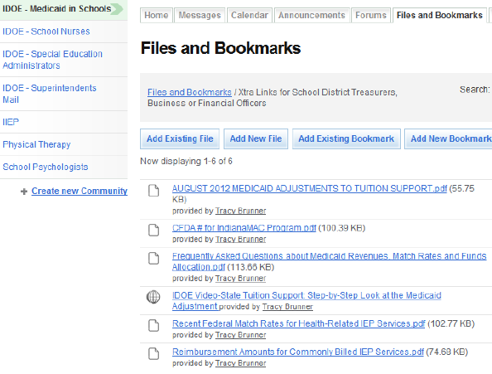
All MAC reimbursements = new unrestricted federal $ to participating districts
School Finance Office explains: participating districts retain all state + 97% of new federal Medicaid $ for IEP-required services
Questions …?

about IEP Services or MAC
contact: tbrunner@doe.in.gov

about MAC
contact: inmac@pcgus.com
Indiana Resource Network

http://www.doe.in.gov/specialed/indiana-resource-network
Project Success
- Project SUCCESS supports teachers and administrators in the design and implementation of Indiana Academic Standards in curriculum and instruction for students with significant cognitive disabilities. This includes providing critical background information and access to instructional and resource materials developed by NCSC. Project SUCCESS provides monthly professional development sessions to participating teams and on-site technical assistance as needed.
- Project Director: Amy Howie
- Website: www.projectsuccessindiana.com
Indiana IEP Resource Center
- The purpose of the Effective and Compliant IEP Resource Center (IEPRC) is to increase Indiana educators’ knowledge and skills that will (a) support the use of Indiana IEP, (b) facilitate the development of compliant IEPs, (c) to provide technical assistance (TA) and professional development (PD) for Indiana educators and staff who are involved in developing IEPs, and (d) to support local educational agencies (LEAs) in the development and use of procedures to ensure compliance and the development of high quality IEPs. The IEPRC will provide an array of professional development and coaching opportunities develop resources and materials, facilitate statewide and regional collaborative networks, and advance the use of statewide technology during the case conference committee (CCC) process.
- Director of the IEP Resource Center: Jolly Piersall
- Website: www.indianaieprc.org
IN*SOURCE
- For over thirty-five years, The Indiana Resource Center for Families with Special Needs (IN*SOURCE) has been committed to its mission of providing to parents, educators, and other community service providers in Indiana, the information and training necessary to assure effective educational programs and appropriate services for children and young adults with disabilities. All that IN*SOURCE does, utilizing a parent-to-parent model, directly relates to the provision of training, information, individual assistance and support, primarily to parents of children, youth and young adults with disabilities. Supported by the U.S. Department of Education and the Indiana Department of Education, IN*SOURCE has set in place a statewide network of staff who serve as program specialists serving Indiana families. In implementing its mission, IN*SOURCE always has and will continue to focus on helping parents, educators and service providers to work together to address common interests or concerns and to support successful outcomes for all students.
- IN*SOURCE is committed to provide support to all of the Resource Centers across all of the Performance and Compliance Indicators especially relating to parent involvement in improving services and results for students with disabilities.
- Executive Director: Richard Burden
- Website: www.insource.org
PATINS Project
- The PATINS Project is a valuable resource for Indiana Local Educational Agencies (LEAs) who have students with an IEP indicating a need for assistive and accessible technologies and alternate formats of printed instructional materials. The PATINS Indiana Center for Accessible Materials (ICAM) can provide specialized formats (Braille, large print, accessible PDFs, audio, digital, and audio digital formats) of K-12 textbooks and core instructional materials. The PATINS Project also provides training and technical assistance to LEA personnel and families who will use these accessible instructional materials to ensure students with disabilities have access to, can participate in, and progress in their educational programs.
- Project Director: Daniel McNulty
- PATINS Project Web Site: http://www.patinsproject.com
- Indiana Center for Accessible Materials (ICAM) Web Site: http://www.icam.k12.in.us/
Promoting Achievement for Students with Sensory Loss (PASS)
- The purpose of the Promoting Achievement for Students with Sensory Loss (PASS) Project is to provide statewide support, technical assistance and professional development opportunities for educators and families that will improve instructional quality, promote academic achievement, and foster successful post-secondary outcomes for students with sensory loss. The PASS Project accomplishes these goals by supporting the Teacher of Exceptional Needs: Visual Impairment licensure program, by providing training opportunities for teachers who serve students who are blind/low vision, by partnering with stakeholders to offer an annual summer conference for teachers who serve students who are deaf/hard of hearing and by providing educational interpreters with opportunities for training in order to improve their interpreting skills. The PASS Project is linked to the federally funded Indiana Deaf-Blind Services Project that provides technical assistance and training to families and educators who serve infants, toddlers, children, and youth who are deaf-blind.
- Project Coordinator: Carol Wetherell
- Website: http://www.indstate.edu/blumberg/dhh/index.htm
Positive Behavioral Interventions and Supports (PBIS)
PBIS INDIANA will develop and establish a statewide network of culturally responsive school-wide positive behavior support sites and increase educators' knowledge and understanding of how PBIS impacts student achievement, family engagement, dropout rate and least restrictive environment placements.
- Project Directors: Dr. Russ Skiba & Dr. Sandi Cole
- Website: http://www.indiana.edu/~pbisin/about/
ADDITIONAL RESOURCES:
- Effective Evaluation Resource Services at Blumberg Center http://www.indianaeerc.org/
- HANDS (Helping Answer Needs by Developing Specialists) in Autism Resource Center https://handsinautism.iupui.edu/index.htm
- Center on Education and Lifelong Learning (CELL) http://www.iidc.indiana.edu/index.php?pageId=30
- Indiana Secondary Transition Resource Center http://www.iidc.indiana.edu/index.php?pageId=3283

Indicators

- Graduation Rate: Percent of youth with IEPs graduating from high school with a regular diploma.
- Dropout: Percent of youth with IEPs dropping out of high school.
- Statewide Assessment: Participation and performance of children with IEPs on statewide assessments:
- Percent of the districts with a disability subgroup that meets the State’s minimum “n” size that meet the State’s AYP/AMO targets for the disability subgroup.
- Participation rate for children with IEPs.
- Proficiency rate for children with IEPs against grade level, modified and alternate academic achievement standards.
- Suspension/Expulsion: Rates of suspension and expulsion:
A. Percent of districts that have a significant discrepancy in the rate of suspensions and expulsions of greater than 10 days in a school year for children with IEPs; and
B. Percent of districts that have: (a) a significant discrepancy, by race or ethnicity, in the rate of suspensions and expulsions of greater than 10 days in a school year for children with IEPs; and (b) policies, procedures or practices that contribute to the significant discrepancy and do not comply with requirements relating to the development and implementation of IEPs, the use of positive behavioral interventions and supports, and procedural safeguards.
- LRE Placement: Percent of children with IEPs aged 6 through 21 served:
A. Inside the regular class 80% or more of the day;
B. Inside the regular class less than 40% of the day; and
C. In separate schools, residential facilities, or homebound/hospital placements.
- Preschool Settings: Percent of children aged 3 through 5 with IEPs attending a:
A. Regular early childhood program and receiving the majority of special education and related services in the regular early childhood program; and
B. Separate special education class, separate school or residential facility.
- Preschool Skills: Percent of preschool children aged 3 through 5 with IEPs who demonstrate improved:
- Positive social-emotional skills (including social relationships);
- Acquisition and use of knowledge and skills (including early language/ communication and early literacy); and
- Use of appropriate behaviors to meet their needs.
- Parent Involvement: Percent of parents with a child receiving special education services who report that schools facilitated parent involvement as a means of improving services and results for children with disabilities.
- Disproportionate Representation in Special Education: Percent of districts with disproportionate representation of racial and ethnic groups in special education and related services that is the result of inappropriate identification.
- Disproportionate Representation in Specific Disability Categories: Percent of districts with disproportionate representation of racial and ethnic groups in specific disability categories that is the result of inappropriate identification.
- Initial Evaluations: Percent of children who were evaluated within 60 days of receiving parental consent for initial evaluation or, if the State establishes a timeframe within which the evaluation must be conducted, within that timeframe.
- Part C to B Transition: Percent of children referred by Part C prior to age 3, who are found eligible for Part B, and who have an IEP developed and implemented by their third birthdays.
- Secondary Transition w/IEP Goals: Percent of youth with IEPs aged 16 and above with an IEP that includes appropriate measurable postsecondary goals that are annually updated and based upon an age appropriate transition assessment, transition services, including courses of study, that will reasonably enable the student to meet those postsecondary goals, and annual IEP goals related to the student’s transition service needs. There also must be evidence that the student was invited to the IEP Team meeting where transition services are to be discussed and evidence that, if appropriate, a representative of any participating agency was invited to the IEP Team meeting with the prior consent of the parent or student who has reached the age of majority.
- Secondary Transition/Post-School Outcomes – Competitive Employment, Enrolled in School: Percent of youth who are no longer in secondary school, had IEPs in effect at the time they left school, and were:
A. Enrolled in higher education within one year of leaving high school.
B. Enrolled in higher education or competitively employed within one year of leaving high school.
C. Enrolled in higher education or in some other postsecondary education or training program; or competitively employed or in some other employment within one year of leaving high school.
- Hearing Requests that Went to Resolution: Percent of hearing requests that went to resolution sessions that were resolved through resolution session settlement agreements.
- Mediations: Percent of mediations held that resulted in mediation agreements.
- Monitoring Priority: The State’s SPP/APR includes a State Systemic Improvement Plan (SSIP) that meets the requirements set forth for this indicator.

Indicator 4A
A Significant Discrepancy in the rate of out-of-school (OSS) suspensions/expulsions greater than ten days of students with disabilities.
What this means: Data that you submitted for your LEA shows that the rate at which students with disabilities are subjected to OSS suspensions/expulsions for more than ten days is at least twice as high as the statewide rate at which students with disabilities are subjected to OSS suspensions/expulsions for more than ten days for two consecutive years.
Example of Indicator 4A calculation
(See the data chart included with your preliminary notice for actual data related to your LEA)
 |  | A | B | C | D
 |  | Total number of students with disabilities | Total out-of school suspensions/expulsions totaling more than 10 days | Incident Rate  B ÷ A | Ratio  LEA incident rate ÷ Statewide incident rate
2011-2012 | Statewide | 149,596 | 2,054 | .0137  (1.37%) | .0484 ÷ .0137 = 3.5274
 | ABC School Corp | 351 | 17 | .0484  (4.84%)
2012-2013 | Statewide | 150,338 | 1,918 | .0127  (1.27%) | .0434 ÷ .0127 = 3.4079
 | ABC School Corp | 345 | 15 | .0434  (4.34%)

Column C: The Statewide incident rate is determined by dividing the total number of students with disabilities in the state who were suspended/expelled (OSS) for more than ten days by the total number of students with disabilities in the state. The LEA’s incident rate is determined by dividing the number of students with disabilities in the LEA who were suspended/expelled (OSS) for more than ten days by the total number of students with disabilities in the LEA.
Column D: The ratio is determined by dividing the LEA’s incident rate by the Statewide incident rate.
Conclusion: For the past two school years, ABC School Corporation has exceeded the 2.0 threshold. The data shows that the LEA has subjected its students with disabilities to out-of-school suspensions/expulsions for more than ten days at rates that are 3.5274 and 3.4079 times the Statewide rate. Further review is necessary to determine if this is the result of inappropriate policies, procedures or practices.

Indicator 4B
A Significant Discrepancy in the rate of out-of-school (OSS) suspensions/expulsions greater than ten days of a particular racial or ethnic group of students with disabilities as compared to all other students with disabilities in your LEA.

What this means: Data that you submitted for your LEA shows that the rate at which a particular racial or ethnic group of students with disabilities is subjected to OSS suspensions/expulsions for more than ten days is at least twice as high as the rate at which all other students with disabilities are subjected to OSS suspensions/expulsions for more than ten days in your LEA.
Comparisons are made using a risk index. The risk index is the percentage of students with disabilities from a particular racial or ethnic group who are suspended/expelled (OSS) for more than ten days. The risk index for a particular racial or ethnic group is compared to the risk index for all other students. “All other students” means all students in the other racial or ethnic categories. For example, in determining if there is a significant discrepancy in the rate at which African American students with disabilities are suspended/expelled for more than ten days, “all other students” would be those students with disabilities who are not African American who are suspended/expelled for more than ten days.
If you received a preliminary notice for Indicator 4B, it means that the data you submitted for your LEA shows that the risk index for students in a particular racial or ethnic group who have been suspended/expelled (OSS) for more than ten days is at least two times greater than the risk index for all other racial or ethnic groups of students with disabilities in your LEA for two consecutive years.
Example of Indicator 4B calculation
(See the data chart included with your preliminary notice for actual data related to your LEA)

 |  | A | B | C | D | E | F | G
 |  | Total Students with Disabilities | African American Students with Disabilities | Total OSS Suspension/  Expulsions totaling more than 10 days | African American OSS Suspension/  Expulsions totaling more than 10 days | Risk Index for African American students with Disabilities  (D) ÷ (B) | Risk Index for all other students with disabilities  (C-D) ÷ (A-B) | Relative Risk Ratio  E ÷ F
2011-12 | XYZ Sch Corp | 3,637 | 1,154 | 119 | 61 | .0528  (5.28%) | .0233  (2.33%) | 2.2629
2012-13 | XYZ Sch Corp | 3,655 | 1,158 | 100 | 51 | .0440  (4.40%) | .0196  (1.96%) | 2.2443
Column E: To determine the risk index for African American students, the number of African American students with disabilities subjected to OSS suspension/ expulsion for more than ten days (Column D) is divided by the total number of African American students with disabilities (Column B).
Column F: The risk index for all other students with disabilities (White, Hispanic, Asian, American Indian/Alaska Native, Native Hawaiian/Other Pacific Islander, and Multiple races) is determined by the total number of students with disabilities subjected to OSS suspension/expulsion for more than ten days (Column C) minus the number of African American students with disabilities subjected to the same discipline (Column D) DIVIDED BY the total number of students with disabilities (Column A) minus the number of African American students with disabilities (Column B).
Column G: The relative risk ratio (comparing African American students with disabilities to all other students with disabilities) is determined by dividing the risk index for African American students (Column E) by the risk index for all other students with disabilities (Column F).
Conclusion: For the past two school years XYZ School Corporation has exceeded the 2.0 threshold for African American students. The data shows that African American students with disabilities have been suspended/expelled (OSS) for more than ten days 2.2629 and 2.2443 times more frequently than all other racial/ethnic groups combined. Further review is necessary to determine if this is the result of inappropriate policies, procedures, or practices.

Indicator 9

A Disproportionate Representation of a particular racial/ethnic group within the total group of students with disabilities.

What this means: Data from the LEA is used to determine if students from one racial or ethnic group are identified more frequently as students with disabilities compared to students in all other racial or ethnic groups.

Comparisons are made using a risk index. The risk index is the percentage of students from a particular racial or ethnic group identified as students with disabilities. The risk index for a particular racial or ethnic group is compared to the risk index for all other students. “All other students” means all students in the other racial or ethnic categories. For example, in determining if there is a disproportionate representation of white students with disabilities, “all other students” would be those students who are not white.

If you received a preliminary notice for Indicator 9, it means that the data you submitted for your LEA shows that the risk index for students in a particular racial or ethnic group identified as students with disabilities is at least two times greater than the risk index for all other racial/ethnic groups of students with disabilities for two consecutive years.

Example of Indicator 9 calculation
(See the data chart included with your preliminary notice for actual data related to your LEA)
 |  | A | B | C | D | E | F | G
 |  | Total Enrollment | Hispanic  Enrollment | Total Number of Students with Disabilities | Number of Hispanic Students with Disabilities | Risk Index for Hispanic Students  (D) ÷ (B) | Risk Index for all other students  (C-D) ÷ (A-B) | Relative Risk Ratio  E ÷ F
2012-13 | Local School Corp | 2,547 | 110 | 402 | 35 | .3181  [31.81%] | .1514  [15.14%] | 2.1013
2013-14 | Local School Corp | 2,623 | 104 | 401 | 29 | .2788  [27.88%] | .1099  [10.99%] | 2.5357
Column E: To determine the risk index for Hispanic students, the number of Hispanic students with disabilities (Column D) is divided by the total number of Hispanic students enrolled in the LEA (Column B).
Column F: The risk index for all other students (White, African-American, Asian, American Indian/Alaska Native, Native Hawaiian/Other Pacific Islander, and Multiple races) is determined by the total number of students with disabilities (Column C) minus the number of Hispanic students with disabilities (Column D) DIVIDED BY the total enrollment (Column A) minus the Hispanic enrollment (Column B).
Column G: The relative risk ratio (comparing Hispanic students with disabilities to all other students with disabilities) is determined by dividing the risk index for Hispanic students (Column E) by the risk index for all other students with disabilities (Column F).
Conclusion: For the past two school years Local School Corporation has exceeded the 2.0 threshold for Hispanic students. The data shows that Hispanic students have been identified as students with disabilities 2.1013 and 2.5357 times more frequently than all other racial/ethnic groups combined. Further review is necessary to determine if this is the result of inappropriate identification of Hispanic students.
Indicator 10

A Disproportionate Representation of a particular racial or ethnic group within a specific disability category compared to all other students in the same disability category.

What this means: Data from the LEA is used to determine if students from one racial or ethnic group are identified more frequently as students in a specific disability category compared to students in all other racial or ethnic groups who are identified in the same disability category.
Comparisons are made using a risk index. The risk index is the percentage of students from a particular racial or ethnic group identified as students in a specific disability category. The risk index for a particular racial or ethnic group is compared to the risk index for all other students in the same disability category. “All other students” means all students in the other racial or ethnic categories. For example, in determining if there is a disproportionate representation of white students with Autism, “all other students” would be all students with Autism who are not white.
If you received a preliminary notice for Indicator 10, it means that the data you submitted for your LEA shows that risk index for students in a particular racial or ethnic group identified as students in a specific disability category is at least two times greater than the risk index for all other racial or ethnic groups of students in the same disability category for two consecutive years.

Example of Indicator 10 calculation
(See the data chart included with your preliminary notice for actual data related to your LEA)
 |  | A | B | C | D | E | F | G
 |  | Total Enrollment | White Enrollment | Total Students with Autism | White Students with Autism | Risk Index for White Students  (D) ÷ (B) | Risk Index for all other students  (C-D) ÷ (A-B) | Relative Risk Ratio  E ÷ F
2012-13 | Friendly School Corp | 3,842 | 2,085 | 52 | 38 | .0182  (1.82%) | .0079  (0.79%) | 2.2872
2013-14 | Friendly School Corp | 3,726 | 1,990 | 64 | 46 | .0231  (2.31%) | .0103  (1.03%) | 2.2293

Column E: To determine the risk index for White students with Autism, the number of White students with Autism (Column D) is divided by the total number of White students enrolled in the LEA (Column B).
Column F: The risk index for all other students (African-American, Asian, American Indian/Alaska Native, Hispanic, Native Hawaiian/Other Pacific Islander, and Multiple races) with Autism is determined by the total number of students with Autism (Column C) minus the number of White students with Autism (Column D) DIVIDED BY the total enrollment (Column A) minus the White enrollment (Column B).
Column G: The relative risk ratio (comparing White students with Autism to all other students with Autism) is determined by dividing the risk index for White students (Column E) by the risk index for all other students (Column F).
Conclusion: For the past two school years Friendly School Corporation has exceeded the 2.0 threshold for White students with Autism. The data shows that White students have been identified students with Autism 2.2872 and 2.2293 times more frequently than all other racial/ethnic groups combined. Further review is necessary to determine if this is the result of inappropriate identification.

Significant Disproportionality: Placement Categories

What this means: Data that you submitted for your LEA shows that students in a particular racial or ethnic group are identified at least 2.5 times more frequently as students in a specific placement category compared to students in all other racial or ethnic groups who are identified in the same placement category for two consecutive years. For Significant Disproportionality determinations, the following placement categories are reviewed: LRE Code 51 (in general education less than 79% but more than 40% of the time; LRE Code 52 (in general education less than 40% of the time; and LRE Codes 53/54 (separate school or residential facility).
Comparisons are made using a risk index. The risk index is the percentage of students from a particular racial or ethnic group identified as students in a specific placement category. The risk index for a particular racial or ethnic group is compared to the risk index for all other students in the same placement category. “All other students” means all students in the other racial or ethnic categories. For example, in determining if there is a significant disproportionality of white students in LRE Code 52 placement, “all other students” would be all students in LRE Code 52 placement who are not white.
Example of Significant Disproportionality calculation
(See the data chart included with your preliminary notice for actual data related to your LEA)
 |  | A | B | C | D | E | F | G
 |  | Total Enrollment | White Enrollment | Total Students in LRE Code 52 Placement | White Students in LRE Code 52 Placement | Risk Index for White Students  (D) ÷ (B) | Risk Index for all other students  (C-D) ÷ (A-B) | Relative Risk Ratio  E ÷ F
2012-13 | ABC School Corp | 3,842 | 2,085 | 49 | 38 | .018225  (1.8225%) | .006260  (0.6260%) | 2.9113
2013-14 | ABC School Corp | 3,726 | 1,990 | 59 | 46 | .023115  (2.3115%) | .0074884  (0.74884%) | 3.0869

Column E: To determine the risk index for White students in LRE Code 52 placement, the number of White students in LRE Code 52 placement (Column D) is divided by the total number of White students enrolled in the LEA (Column B).
Column F: The risk index for all other students (African-American, Asian, American Indian/Alaska Native, Hispanic, Native Hawaiian/Other Pacific Islander, and Multiple races) in LRE Code 52 Placement is determined by the total number of students in LRE Code 52 placement (Column C) minus the number of White students in LRE Code 52 Placement (Column D) DIVIDED BY the total enrollment (Column A) minus the White enrollment (Column B).
Column G: The relative risk ratio (comparing White students in LRE Code 52 placement to all other students in LRE Code 52 placement) is determined by dividing the risk index for White students (Column E) by the risk index for all other students (Column F).
Conclusion: For the past two school years ABC School Corporation has exceeded the 2.5 threshold for White students in LRE Code 52 placement. The data shows that White students have been placed in the LRE Code 52 placement 2.9113 and 3.0869 times more frequently than all other racial/ethnic groups combined. The Relative Risk Ratio of greater than 2.5 for two consecutive years results in a Significant Disproportionality determination.

Significant Disproportionality: Disciplinary Action
What this means: Data that you submitted for your LEA shows that a particular racial or ethnic group of students with disabilities is subjected to one of the following disciplinary actions at least 2.5 times more frequently than all other students with disabilities who are subjected to the same disciplinary action in your LEA for two consecutive years: (a) in-school suspensions totaling 10 days or less; (b) in-school suspensions greater than 10 days; (c) out-of-school suspensions totaling 10 days or less; (d) out-of-school suspensions greater than 10 days; and (e) total number of disciplinary removals.
Comparisons are made using a risk index. The risk index is the percentage of students with disabilities from a particular racial or ethnic group who are subjected to a specific disciplinary action. The risk index for a particular racial or ethnic group is compared to the risk index for all other students. “All other students” means all students in the other racial or ethnic categories. For example, in determining if there is a significant disproportionality for African-American students with disabilities being subjected to a specific disciplinary action, “all other students” would be those students with disabilities who are not African American who are subjected to the same disciplinary action.
Example of Significant Disproportionality (See the data chart included with your preliminary notice for actual data related to your LEA)
 |  | A | B | C | D | E | F | G
 |  | Total Students with Disabilities | African American Students with Disabilities | Total OSS  totaling more than 10 days | African American OSS  totaling more than 10 days | Risk Index for African American students  (D) ÷ (B) | Risk Index for all other students with disabilities  (C-D) ÷ (A-B) | Relative Risk Ratio  E ÷ F
2011-12 | XYZ Sch Corp | 3,637 | 1,054 | 119 | 71 | .067362  (6.7362%) | .018583  (1.8583%) | 3.6249
2012-13 | XYZ Sch Corp | 3,655 | 1,011 | 95 | 61 | .060336  (6.0336%) | .012859  (1.2859%) | 4.6921
Column E: To determine the risk index for African American students, the number of African American students with disabilities subjected to OSS for more than ten days (Column D) is divided by the total number of African American students with disabilities (Column B). Note: When the Significant Disproportionality discipline category is “Total Disciplinary Removals,” the Risk Index is calculated as the result of D÷B multiplied by 100.
Column F: The risk index for all other students with disabilities (White, Hispanic, Asian, American Indian/Alaska Native, Native Hawaiian/Other Pacific Islander, and Multiple races) is determined by the total number of students with disabilities subjected to OSS for more than ten days (Column C) minus the number of African American students with disabilities subjected to the same discipline (Column D) DIVIDED BY the total number of students with disabilities (Column A) minus the number of African American students with disabilities (Column B). Note: When the Significant Disproportionality discipline category is “Total Disciplinary Removals,” the Risk Index is calculated as the result of (C-D) ÷ (A-B) multiplied by 100.
Column G: The relative risk ratio (comparing African American students with disabilities to all other students with disabilities) is determined by dividing the risk index for African American students (Column E) by the risk index for all other students with disabilities (Column F).
Conclusion: For the past two school years XYZ School Corporation has exceeded the 2.5 threshold for African American students. The data shows that African American students with disabilities have been OSS for more than ten days 3.6249 and 4.6921 times more frequently than all other racial/ethnic groups combined. The Relative Risk Ratio of greater than 2.5 for two consecutive years results in a Significant Disproportionality determination.

Significant Disproportionality: Eligibility Categories
What this means: Data that you submitted for your LEA shows that students in a particular racial or ethnic group are identified at least 2.5 times more frequently as students in a specific disability category compared to students in all other racial or ethnic groups who are identified in the same disability category for two consecutive years. For Significant Disproportionality determinations, the following eligibility categories are reviewed: Cognitive Disability; Specific Learning Disability; Emotional Disability; Language/Speech Impairment; Other Health Impairment; and Autism Spectrum Disorder.
Comparisons are made using a risk index. The risk index is the percentage of students from a particular racial or ethnic group identified as students in a specific disability category. The risk index for a particular racial or ethnic group is compared to the risk index for all other students in the same disability category. “All other students” means all students in the other racial or ethnic categories. For example, in determining if there is a significant disproportionality of white students with Autism, “all other students” would be all students with Autism who are not white.
Example of Significant Disproportionality calculation (See the data chart included with your preliminary notice for actual data related to your LEA)
 |  | A | B | C | D | E | F | G
 |  | Total Enrollment | White Enrollment | Total Students with Autism | White Students with Autism | Risk Index for White Students  (D) ÷ (B) | Risk Index for all other students  (C-D) ÷ (A-B) | Relative Risk Ratio  E ÷ F
2012-13 | ABC School Corp | 3,842 | 2,085 | 49 | 38 | .018225  (1.8225%) | .006260  (0.6260%) | 2.9113
2013-14 | ABC School Corp | 3,726 | 1,990 | 59 | 46 | .023115  (2.3115%) | .0074884  (0.74884%) | 3.0869

Column E: To determine the risk index for White students with Autism, the number of White students with Autism (Column D) is divided by the total number of White students enrolled in the LEA (Column B).
Column F: The risk index for all other students (African-American, Asian, American Indian/Alaska Native, Hispanic, Native Hawaiian/Other Pacific Islander, and Multiple races) with Autism is determined by the total number of students with Autism (Column C) minus the number of White students with Autism (Column D) DIVIDED BY the total enrollment (Column A) minus the White enrollment (Column B).
Column G: The relative risk ratio (comparing White students with Autism to all other students with Autism) is determined by dividing the risk index for White students (Column E) by the risk index for all other students (Column F).
Conclusion: For the past two school years the ABC School Corporation has exceeded the 2.5 threshold for White students with Autism. The data shows that White students have been identified students with Autism 2.9113 and 3.0869 times more frequently than all other racial/ethnic groups combined. The Relative Risk Ratio of greater than 2.5 for two consecutive years results in a Significant Disproportionality determination.

Indicator 5: Least Restrictive Environment
Myths Debunked
LRE does NOT determine funding
- Funding is determined by the student’s eligibility area

LRE and Services Delivered are not the same thing
- Many districts mistakenly code students as 51 (21%-60% in separate special education classes) because the code description uses the words “Resource Room”.
- Additionally students in “Work Study” programs in the community are often coded as a 52. The time they are working should be considered general education, unless it occurs in a setting that only serves people with disabilities (i.e. Sheltered workshop).

LRE does not describe the type of classroom
- LRE describes the level of access and participation to the grade level curriculum with non-disabled peers.
- May include passing, lunch, and recess times based on the student’s need, skill development, and goal attainment.
- The general make-up and curriculum taught determine whether instructional minutes are counted as General Education or Special Education minutes.

LRE is NOT based on Disability or Eligibility Determination
- General Education is defined as at least 51% of the class is made up of general education students, covering grade level standards at a standard pace.

Indicator 11-Timeline Guidance
The timeline for an initial evaluation begins with the LEA’s receipt of written parental consent. [50 days: 511 IAC 7-40-5(d), 20 days: 511 IAC 7-40-2 and 511 IAC 7-44-9] As related to Indicator 11 there are three allowable exceptions for not conducting the evaluation and convening the case conference committee within the applicable timeline. The allowable exceptions are:
- When a student enrolls in a school of another LEA after the relevant 50 or 20 instructional day timeline has begun and prior to completion of the evaluation, if the:
  - Subsequent LEA is making sufficient progress to ensure a prompt completion of the evaluation; and
  - Parent and subsequent LEA agree to a specific time when the evaluation will be completed.
- Parent revoked consent for evaluation prior to completion of the evaluation.
- When the parent of a student repeatedly fails or refuses to produce the student for the evaluation.

Please note that when you utilize code “99” in the DOE-EV to document that the case conference committee did not convene because the parent was unavailable to participate, this does not constitute an allowable exception for exceeding the evaluation timeline.
In the event that an LEA is unable to arrange parent participation in an initial case conference committee meeting either in person or by alternate means as described in 511 IAC 7-42-2(a), within the 50 or 20 instructional day timeline, IDOE recommends that the LEA convene a case conference committee meeting prior to the expiration of the timeline. The LEA must document the attempts that were made to contact the parents to make arrangements for them to participate in the meeting. This will be a very short meeting to document that: (1) the committee convened for the purpose of discussing the results of the initial evaluation; (2) the parents were unable to attend or otherwise participate; and (3) the case conference committee will reconvene when parents are available to attend. Actual determination of the student’s eligibility should not be made until the parent participates in the case conference committee meeting. The LEA should continue efforts to find mutually agreed upon time(s) to reconvene the case conference.

EV Report and Indicators 11 & 12

This document has been designed to assist LEAs in understanding the relationship between the EV Report and CL Report, and the monitoring of Special Education Federal Indicators 11 and 12.

Things to Remember
- School calendars are an important component of our analysis of the data submitted on the EV Report. The school calendar submitted at the end of the school year via the CL Report is used to make timeline calculations.
  - It is important that schools update calendars in the CL Report (CL Report requires calendars to be updated within 5 days of the end of the school year or June 21st, whichever comes first) to reflect snow days, emergency days or any other days when students were not in attendance.
- Codes used to designate the reason a timeline was missed on the EV Report should be cross referenced with the EV layout description and individual student file documentation to verify that the reason matches.
- Any student that has “Code 99” for reason missed will require an explanation during the data verification window. Some of the codes are “allowable” reasons for timelines to be missed; others are not, so we will ask for more detail when Code 99 is used.
- IDOE will analyze the data and give LEAs the opportunities to verify any discrepancies. The LEA will have two weeks to provide additional information to make corrections if applicable. LEAs will be notified by Education Specialists regarding specific verification needs and timelines.
  - It is encouraged that multiple staff review submission information, or the LEA have a process of ensuring data reporting accuracy.
Common Errors
We recommend that as the CL Report is updated and prior to submission of the EV Report, double check your data in order to avoid these common errors:
- Data Entry Errors on CL Report
- School Calendars are not updated through the CL Report and are not a reflection of the actual school year.
- Data Entry errors on the EV report
  - Dates transposed
  - Conference date is shown as a date prior to referral date;
  - Birthdates listed incorrectly therefore age is calculated incorrectly
  - Incorrect school years entered
  - Incorrect timeline code entered
  - Incorrect coding of EV Type, Reason Missed, etc.

Indicator 13: Secondary Transition

Assessments/Postsecondary Goals
Is there evidence that the measureable postsecondary goal is based on age-appropriate transition assessments?  (Summary of Transition Assessment Findings) | Postsecondary Goal Area  (Examples)
- Have 1 or more assessments been given for each of the postsecondary goal areas - Employment, Education/Training and, if needed, Independent Living within the last year? OR Has 1 assessment been given that provides information for each of the postsecondary areas?  - Are the names of the assessments and dates administered listed?  - If there is no Independent Living postsecondary goal, is there evidence as to why one is not needed?  - Are each assessment’s results summarized?  - Does the assessment summary include information about the student’s needs taking into account his/her strengths, interests and preferences?  - Do the “I will” postsecondary goal statements match the information found in the summary of transition assessment?  - Does the transition assessment summary include input from the student and parents?  - Are the assessments updated annually and age-appropriate? | - Education/Training- Kayla completed a Career Clusters and the Student/Parent Interview Form with the teacher of record. Kayla is a 21st Century Scholar. She is interested in being a surgery nurse. Kayla has viewed nursing options and various universities’ nursing options. She has an interest in attending classes at the Career Center during high school, volunteering or working at a hospital, and job shadowing persons in the medical field.  - Employment-Kyle completed the “What’s My Bag?” transition assessment. He is interested in doing something that involves semi- trucks. He is also interested in washing dishes for a restaurant or doing farm work.  - Independent Living-Doug has chores at home that include mowing the lawn, picking up sticks, and cleaning his room. Doug’s mom completed a survey called Life Skills Inventory. According to the results, Doug needs to acquire basic skills in transportation and interpersonal skills. He needs some support and reminders with his grooming and hygiene.  - Independent Living-Non Applicable: Keisha has had to perform many of independent living activities as her mother is frequently ill and hospitalized. She goes grocery shopping and can prepare and cook meals. She can clean the home she lives in. She can make appropriate choices for what to wear to school. She can perform basic money management skills.
Online training module: http://connect.iu.edu/transitionassessment
For a list of over 70 transition assessment see: http://www.instrc.indiana.edu/ Click on Transition Assessment Matrix

Indicator 13 (cont.)
Is/Are there measureable annual transition IEP goal(s) that are related to the student’s postsecondary goals? | Are there transition services in the Transition IEP that will enable the student to meet his/her postsecondary goals?
- Do the annual goals relate to the student’s identified need?  - Are the annual goals based upon baseline data (present levels)?  - Are the annual goals related to the barriers the student is having in making progress in the general education curriculum?  - Are you able to determine when the student will meet his/her goal? (criteria/mastery and progress monitoring)  - Is there an annual goal which is supporting the student to acquire the skills necessary to attain each of his/her postsecondary goals?  - If you have an Independent Living postsecondary goal, do you have an annual goal to support it?  - If a student has a postsecondary goal in the area of independent living, is/are there annual goals to support it? | - Are services and activities aligned with each postsecondary goal (e.g., If you have an ILS goal, do you have transition services to support it)?  - Does the school share responsibility for provision and implementation of services and activities?  - Do the services and activities fall within the duration of the IEP?  - Is it a transition service and activity and not a special education service?  - Do the services/ activities assist the student to refine his or her postsecondary goals or gain skills needed to achieve a specific postsecondary goal?  If a class (not core class) is listed as a transition service/activity, have you noted the connection to a postsecondary goal(s)? If not, did you describe why there is not an obvious connection?
Additional Resource: for Transition Services and Activities: Definition and Examples, a 12-page booklet of the definition and examples for transition services and activities, go to -http://www.iidc.indiana.edu/styles/iidc/defiles/INSTRC/Transition_Services_and_Activities_Definition_and_Examples.pdf

ESEA Flexibility Waiver

What is the ESEA Flexibility Waiver?
- A waiver of specific ESEA (NCLB) requirements in exchange for plan for better outcomes
- SEA and LEAs gain flexibility to better focus on improving student learning and increasing the quality of instruction
- In exchange for flexibility, State must provide “rigorous State-developed plans designed to improve educational outcomes for all students, close achievement gaps, increase equity, and improve the quality of instruction”
- Examples of flexibility:
  - Implementation of school improvement requirements
  - Allocation of ESEA funds to serve priority or focus school
  - Use of School Improvement Grant Funds to support priority schools
  - Accountability determinations not utilizing AYP

Rigorous plans…
- (Principle 1) College and career ready expectations for ALL students
- This new law, Indiana Code 20-19-2-14.5, established the timeline for the review and adoption of new K-12 academic standards
- The new law outlined a rigorous review of all aspects of K-12 academic standards for E/LA and mathematics
- Adopted by the State Board April 2014 (earlier than July 1, 2014 deadline)
- (Principle 1) Statewide assessments
  - Aligned to CCR standards
  - Measure student growth
  - Will be aligned to new college and career ready 2014 Indiana Academic Standards
  - ISTEP+
    - New E/LA and Math ISTEP+ assessments are being developed
    - Science and Social Studies won’t change
  - New alternate assessment (NCSC)
    - Two pilots
  - IMAST no longer available-transition webinar series online
  - Administered in Spring 2015
- (Principle 2) Differentiated recognition, accountability, and support for all LEAs
  - Student achievement
  - Graduation rates
  - School performance
- (Principle 3) Supporting Effective Instruction and Leadership
- Teacher and principal evaluation and support systems
- During the 2013 session, the General Assembly passed Public Law 286

What does this mean for students with disabilities?
- Need to ensure a smooth transition in instructing and assessing students on the new college and career ready 2014 Indiana Academic Standards
  - Universal design for learning
  - Accommodations
  - Assistive Technology
  - IEP goals aligned to new standards

Special Education Resources:
- Online Needs survey for special education teachers and administrators (available 7/31/14)
- Online Communities of Practice (3 Special Education Communities) http://www.doe.in.gov/elearning/online-communities-practice
- Resources on IDOE hub page (all educators)
- Summer eLearning Conferences (all educators)
- Project SUCCESS summer trainings
- Statewide Assessment Resource Guide and Toolkit http://www.doe.in.gov/sites/default/files/assessment/accommodations-resource-guide-and-toolkitrevised-july-2014.pdf
- IMAST Webinars http://www.doe.in.gov/specialed

General Supports from IDOE http://www.doe.in.gov.standards
- Standards correlations
- Instructional and assessment guidance
- Teacher resource guides
- Online Communities of Practice http://www.doe.in.gov/elearning/online-communities-practice

OFFICE OF SPECIAL EDUCATION STAFF DIRECTORY

NAME | EMAIL | PHONE | RESPONSIBILITIES
Becky Bowman | bbowman@doe.in.gov | 317-232-6622 | Director of Special Education
Nancy Zemaitis | nzemaitis@doe.in.gov | 317-232-0568 | Assistant Director
Dana Long | dalong@doe.in.gov | 317-232-6675 | Due Process Coordinator/Attorney
Kim Payton | kpayton@doe.in.gov | 317-233-2131 | Support Specialist, Due Process
Traci Tetrick | ttetrick@doe.in.gov | 317-232-9062 | Complaint Investigator
Jennifer Simpson | jsimpson@doe.in.gov | 317-232-0575 | Complaint Investigator
Tracy Brunner | tbrunner@doe.in.gov | 317-232-0570 | Medicaid Specialist
Robin Parker | rparker@doe.in.gov | 317-232-0864 | Data Manager
Trennie Waddell | pwaddell@doe.in.gov | 317-232-0585 | Support Specialist, Excess Cost
Susan Reimlinger | sreimlin@doe.in.gov | 317-232-0570 | Supervisor, Excess Costs
Sarah Henry | slhenry@doe.in.gov | 317-232-0586 | Support Specialist, Federal Funding
Jen Thompson | jthompson@doe.in.gov | 317-234-1002 | Part B Grants Supervisor
Kristan Sievers-Coffer | ksievers@doe.in.gov | 317-232-0595 | IRNs, Indicators 4, 9, 10, Significant Disproportionality, Alternate Assessment
Becky Reed | rreed@doe.in.gov | 317-234-4746 | Indicators 5, 11, 17
Chris Furbee | cfurbee@doe.in.gov | 317-232-9142 | Indicators 6, 7, 8, 12, 14, All preschool and ESL Inquiries
Steve Yockey | syockey@doe.in.gov | 317-232-9065 | Indicator 13
Lesa Paddack | lpaddack@doe.in.gov | 317-232-0892 | IN*SOURCE

Developed by Dr. Teresa Grossi, Indiana Secondary Transition Resource Center, Indiana University

